Improving Customer Retention Through Predictive Machine Learning

Group 1: Israel Alcocer, Samuel A. Escobar, Jose Gabriel Lopez-Reyes, Kyle Mitchell, Angel Rosales
Department of Computer Science, California State University, Northridge
COMP 442: Machine Learning
Dr. Taehyung Wang
July 6th, 2026

Business Understanding 4
Executive Summary 4
Project Background 4
Business Objectives 5
Business Success Criteria 5
Inventory of Resources 6
Requirements, Assumptions, and Constraints 7
Risks and Contingencies 8
Terminology 8
Costs and Benefits 9
Machine Learning Goals 11
Project Plan 11
Initial Assessment of Tools and Techniques 15
Team and Expertise 16
Expected Outcomes 19
Impact and Significance 20
Conclusion 21
Data Collection 22
Data Source 22
Minimum Data Specifications 22
Ethical and Legal Considerations 23
Data Understanding and Preprocessing 24
Dataset Profile 24
Exploratory Data Analysis 24
Data Preprocessing Pipeline 25
Model Selection, Architecture, and Training 26
Model Selection and Justification 26
Architecture Description 26
Training Configuration 27
Baseline Model 27
Hyperparameter Tuning 28
Evaluation, Model Comparison, and Deployment 29
Evaluation Protocol 29
Performance Metrics 29
Model Comparison 29
Ablation Study 30
Final Model Selection 30
Error Analysis 30
Deployment Plan 30
Summary of Learning Experiences 32
References 33
Appendix 34

Executive Summary:

Customer churn is a challenge for companies because keeping existing customers is more cost-effective than spending to acquire new customers. The project attempts to address this problem by predicting customer churn by using historical data from the Telco Customer Churn Dataset. By identifying customers who are likely to churn, companies can target groups or factors related to churn to increase retention. Like offering deals for certain demographics, incentives for contracts, or enhanced customer service.

In an effort to solve this problem, multiple machine learning classification models were implemented and tested, specifically, Logistic Regression, Decision Tree, and Random Forest which were all developed and evaluated. The dataset, while generally clean, needed to be further cleaned, preprocessed, and encoded as well as balanced using SMOTE before the models could begin training. Model performance was evaluated using a five-fold cross validation that was measured by Accuracy, Precision, Recall, F1 Score, and Confusion Matrices. Logistic Regression saw the highest overall performance with the highest Recall and F1 Score. This solution to identify churning customers combines machine learning models and many evaluation techniques to provide predictions that could increase customer retention for more businesses.

Project Background:

Customer retention is a critical concern in industries like telecommunications because there is a lot of cost associated with getting new customers subscribed or involved. The market is also very competitive, with customers being able to easily switch providers based on pricing, service quality, and many other factors. This means that customer churn has a large impact on revenue for these companies. Predicting which customers are likely to churn gives companies insight to create retention strategies before customers choose to churn in an attempt to change their minds.

This project uses the Telco Customer Churn Dataset which carries an array of information about customers like account information, services they are subscribed to, billing details, contract information, etc. Using this information business managers, marketing, and customer service departments have to figure out how to target customers to increase retention. By using the project proposed in this report, this historical data can be changed into actionable information for these groups and make their decisions and overall jobs easier to accomplish.

Business Objectives:

The main business objective of this project is to reduce customer churn by detecting customers who are more likely to churn, or cancel, their services. This project can also lead businesses to ask additional questions to help reduce churn:

- Which customer features are strongly associated with churn?
- Do contract types affect customer churn?
- Does a specific payment method lead to higher churn?
- Are customers with extra services less likely to churn?

By answering these questions businesses can develop better customer retention strategies.

Business Success Criteria:

The success criteria for this project is based on the development of a model that can accurately identify customers that may churn, enabling the company to take actions to prevent their cancellation of their services. Technically, the model should have strong performance with high scores in evaluation metrics like Recall and F1 Score to ensure that the majority of customers that are likely to churn are correctly identified.

Success Criterion | Measure
Accurately identify customers who will churn | High Recall and F1 Score
Provide reliable churn predictions | Evaluate models using many metrics: Accuracy, Precision, Recall, F1 Score, and a Confusion Matrix
Identify important churn factors | Analysis of Feature importance and correlation analysis
Support retention | Could be implemented by business managers or marketing teams
Compare multiple machine learning models for the best performance | Logistic Regression, Decision Tree, and Random Forest would be implemented

Inventory of Resources:

Personnel:
Included five students with experience in programming, data analysis, and machine learning concepts. The team collaborated on data collection, data preprocessing, model development, evaluation, documentation, and presentation preparation.

Data:
The project used the Telco Customer Churn Dataset which was sourced from Kaggle. The dataset is a fixed extract with customer historical data, and there was no live, warehoused, or operational data included in the dataset.

Hardware Resources:
Included personal computers and laptops owned by team members on both Windows based and MacOS systems.

Software Resources:
Included multiple machine learning tools. The programming language in use was Python. The development environment used by the team was Google Colab for consistent collaboration. Additional libraries were also used to begin importing data, feature engineering, and the evaluation of results. These libraries included but were not limited to: pandas, NumPy, scikit-learn, SMOTE, and matplotlib.

Additional Resources:
Included the CRISP-DM 1.0 methodology which served as a guiding model for the project team to emulate.

Requirements, Assumptions, and Constraints:

Requirements:
The project was required to follow the guidelines defined by the CRISP-DM methodology and be completed within the timeframe of the course. This led to the milestone requirements being: Data Acquisition, Exploratory Data Analysis, Data Preprocessing, Feature Engineering, Model Development, and Model Evaluation. Models were required to create accurate and easy to interpret results. They also had to be evaluated by multiple metrics after they had been run with an emphasis on Recall and F1 Score.

Assumptions:
The main assumptions that were made through the course of the project were in regards to the dataset that had been acquired. Historical data had to be assumed to be representative of a typical customer’s behavior and the patterns seen within could be used to predict future churn. There was also the assumption that the relationship between customer attributes and churn was stable over time.

Constraints:
The main constraint of the project was the timeframe which it had to be completed in. The seven week schedule of this course was a limiter on how much time was left for proper feature engineering, optimization, and general experimentation with the properties of the project. The computational resources of Google Colab were sufficient for the size of our dataset, but could pose a problem for a company with a larger dataset.

Risks and Contingencies:

There were a handful of risks that threatened the completion of this project. Namely missing or unclean data, a large class imbalance, potential overfitting of training data, the small timeframe for the project, final results that could be complicated to explain, and code that may not be reproducible. For each of these risks we developed a simple contingency table:

Risk Description | Contingency plan
Categorical data is not encoded correctly | Check encoded columns before training and make sure all model inputs are numeric
Missing or blank values affect training | Convert TotalCharges to numeric and remove or fill missing values
Model predicts mostly “No Churn” because of class imbalance | Use precision, recall, F1-score, and confusion matrix instead of only accuracy
Model overfits training data | Use train/test split and compare training vs testing performance
We run out of time for the project | Divide tasks clearly and finish required parts first
Final results are hard to explain | Use simple charts, clear tables, and basic model comparison
Code is not reproducible | Use a fixed random seed and include a README or notebook instructions

Terminology:

Business Terminology:

Churn: Refers to the event where a customer stops using a company’s service.
Retention: The company’s ability to keep existing customers over a span of time.
Contract Type: The type of agreement a customer has with a company, typically payment per month for a specific service.
Retention Strategy: Actions that businesses take to reduce churn and keep customers longer.

Machine Learning Terminology:

Target Variable: The output that the model is trying to predict, like a “Yes” or “No” for a customer’s likelihood to churn.
Classification: A type of machine learning algorithm where the model predicts categories data falls into. Like whether a customer is a “Yes” or “No.”
Training Data: The portion of a dataset that is set aside to train models.
Testing Data: The portion of a dataset that is set aside to test models after they are trained.
Overfitting: When a model learns noise or patterns that could cause it to perform poorly on new test data after it has been trained.
Feature Engineering: The process of transforming raw data to inputs that a model can understand.
Normalization: Adjusting numerical values to a common range so that the models treat features fairly and don’t get bloated by outliers.
SMOTE: Synthetic Minority Over-Sampling Technique, a method used to balance imbalance datasets by generating synthetic samples of the minority class.
Accuracy: comparing how the model accurately predicts the final outcome
Precision: The proportion of predicted churn cases that the model got correct.
Recall: The proportion of actual churn cases that the model correctly identified.
F1-Score: A balance between Precision and Recall, mainly used to measure imbalanced model performance.
Confusion Matrix: A table that shows the model prediction performance across true positives, false positives, true negatives, and false negatives.

Costs and Benefits:

Project Costs:
- Time and Effort
- The time invested in the project is the main investment made by the team, there were no wages but the team had to spend 2-4 hours every week working on the project and an additional 1-2 hours weekly to report and record findings.
- Computational Resources
- Google Colab was free to use for development and each team member used their own device, which brought computational costs to $0.
- Software and Libraries
- The project used entirely open-source tools like Pandas, NumPy, Scikit-learn, Matplotlib, and SMOTE which cost nothing to implement.
- Data Resources
- The Telco Customer Churn Dataset was sourced through the publicly available repository Kaggle. Therefore there were no licensing or acquisition fees for the data needed.

Project Benefits:

- Customer Retention Improvement
- Customer retention should improve by enabling early identification of customers who are likely to churn, thus allowing businesses to implement proactive retention strategies.
- Improved Decision Making
- The final model should be able to provide businesses insights to make decisions regarding key churn drivers or features like Contact Type, Charges, Tenure, etc.
- Targeted Retention Strategies
- Companies would be able to use the information gathered through their Decision Making and Retention Improvement Steps to create Retention Strategies targeting certain people to make efficient use of their resources.

Machine Learning Goals:

- Reduce Customer Churn Rate
- Develop a classification model that predicts whether a customer is likely to churn using their historical data. It should be able to identify at-risk customers early allowing for intervention.
- Identify Key Drivers of Customer Churn
- Apply machine learning models to quantify the contributions that each feature makes to the chance of a customer to churn. This can be used in conjunction with correlation analysis to identify influential predictors for customer churn
- Support Data Driven Decision Making
- There should be a clean pipeline involving preprocessing, encoding, scaling/normalization, and classification models in a reproducible order to ensure interpretable and actionable outputs for businesses to integrate into decision making processes.

Project Plan:

The Project Plan is outlined by a series of phases each with a title and set of tasks that define what happens in them. Each phase also includes a set of outputs, dependencies, and risks.

Phase 1: Business Understanding and Project Planning
- Duration: 1 week
- Tasks:
- Define business objectives and machine learning goals
- Identify project requirements, risks, and constraints
- Discuss team responsibilities
- Outputs
- Completed Proposal
- Defined Objectives
- Initial Project Timeline
- Dependencies
- The team must agree on the project direction.
- Risks
- The scope of the project could become too large. The contingency for this is to focus on churn classification and evaluation metrics to avoid extra noise or scope growth.

Phase 2: Understanding Data and Data Analysis
- Duration: 1 week
- Tasks:
- Inspect the dataset thoroughly
- Begin analysis of data
- Identify missing values, outliers, or potential class imbalance
- Generate visualizations if necessary to understand trends
- Resources
- Python, Pandas, NumPy, Matplotlib
- Outputs:
- Data analysis report
- Assessment of data quality
- Preprocessing requirements
- Dependencies:
- Relies on Phase 1 being completed
- Risks:
- Poor data quality. The contingency is applying preprocessing methods to adjust the data.

Phase 3: Data Preprocessing and Feature Engineering
- Duration: 1 week
- Tasks:
- Handle missing values
- Apply numerical values to categorical variables if necessary
- Normalize numerical features
- Perform feature engineering
- Address class imbalance if present
- Split the dataset into training and testing sets
- Resources
- Scikit-learn, Imbalanced-learn
- Outputs
- Preprocessed dataset
- Feature engineered dataset
- Machine learning algorithms introduced
- Dependencies
- Completion of Data Analysis in Phase 2
- Risks
- Engineered features could reduce model performance. The contingency for this is to remove or modify ineffective features.

Phase 4: Model Development
- Duration: 1 week
- Tasks:
- Train multiple machine learning models
- Compare performance of machine learning models
- Conduct cross validation on models
- Resources
- Scikit-learn (Houses models like Logistic Regression, Decision Tree, and Random Forest)
- Outputs
- Trained machine learning models
- Initial performance comparisons
- Dependencies
- Completion of preprocessing in Phase 3
- Risks
- Risk of overfitting or low accuracy. The contingency for this is to adjust feature selection accordingly.

Phase 5: Model Evaluation and Analysis
- Duration: 1 week
- Tasks:
- Evaluate models using multiple metrics
- Analyze importance of features on each model
- Analyze errors
- Resources:
- Scikit-learn (Houses evaluation metrics like Accuracy, Precision, Recall, F1 Score, etc.)
- Outputs:
- Final model evaluation
- Visualizations of performance
- Written conclusion based on results
- Dependencies:
- Completion of model development in Phase 4
- Risks:
- Inconsistent evaluation results. The contingency for this is that additional evaluation metrics can be used along with repeated testing.

Phase 6: Final Documentation
- Duration: 1 week
- Tasks:
- Complete a final written report
- Create presentation slides
- Finalize visualizations and conclusions
- Resources:
- Google Docs and Google Slides
- Outputs:
- Final Report
- Presentation Slides
- Dependencies:
- Completion of all previous phases
- Risks:
- Delays in pushing final deliverables. The contingency for this is to divide report and slide tasks among group members.

Initial Assessment of Tools and Techniques:

There are a wide assortment of tools and techniques that are utilized in this project to bring the idea of predicting customer churn and retention to a usable model for businesses.

1. Programming Language
- Python is the primary programming language used for this project. It is widely adopted in machine learning and data science disciplines. There are many libraries that are compatible with the language and can be used for this project. The language can also easily be integrated into Google Colab.
2. Data Handling and Preprocessing Tools
- Pandas is a tool used for data loading and cleaning. It is extremely efficient at handling tabular, structured data and has built-in functions that simplify preprocessing steps.
- NumPy is a tool for numerical calculations and operations that can be performed on data. It provides most basic operations that would be needed for any mathematics required in the project.
3. Data Visualization Tools
- Matplotlib is the main library used for visualizations in the project. It provides control over low-level aspects of graphs and charts which allows the team to have control over how the data is represented.
4. Model Tools
- Scikit-learn is the primary library for implementing machine learning models. It provides built-in models like Logistic Regression, Decision Tree, and Random Forest as well as tools for implementing cross validation splits and metrics for evaluation the performance of models.
- SMOTE is used to address the class imbalance in the churn data. SMOTE generates synthetic minority samples to improve model learning. This drastically increases recall and F1-score for the models when they run their testing.
5. Development Environment
- Google Colab is the only development environment that the team used. There is no local setup required and it has easy integration with Google Drive for dataset storage. Due to its accessibility it supports rapid experimentation and collaboration.

6. Machine Learning Techniques
- Supervised Learning is the main machine learning technique used in this project. This is because churn prediction is a binary problem and supervised learning models can learn the relationships between customer features and their likelihood to churn.

7. Evaluation Techniques
- Cross Validation is used to practice performance with multiple sets of test and training data. This gives the team a better understanding of the model’s performance and reliability with new data.
- Evaluation Metrics that were used were Accuracy, Precision, Recall, and F1-Score. These were important, specifically Recall and F1-Score, because they can measure the amount of customers that chose to churn that the model missed. Especially when using an imbalanced dataset, it is important to measure how accurate the model is at predicting the outcome correctly.

Team and Expertise:

Israel Alcocer:
- Israel had little experience with machine learning, but worked to understand how models interpreted data. He was responsible for developing and evaluating the Decision Tree classifier model. He also contributed to project reports and presentation slides, typically taking on 2-3 slides covering a portion of the report.
- Responsibilities:
- Train the Decision Tree model
- Aid with model comparison charts
- Work with team members to compare model performance to all models

Samuel A. Escobar:
- Samuel had intermediate experience with machine learning, he was also aware of assets used in the project beforehand. Additionally he brought his expertise to structuring the code in a legible and organized way to depict a straightforward machine learning pipeline. He was responsible for developing and evaluating the Logistic Regression model and preparing visualizations for comparing model performance. He also contributed to project reports and presentation slides, typically taking on 2-3 slides covering a portion of the report.
- Responsibilities:
- Train the Logistic Regression model
- Create model comparison charts
- Work with team members to compare model performance to all models
- Contribute to reports and presentations
Jose Gabriel Lopez-Reyes:
- Jose had minimal experience with machine learning, he spent the bulk of his time understanding the pipeline from data to output focusing on understanding the Random Forest model. He was responsible for implementing the Random Forest model and evaluating its performance. Since Random Forest was the final model to be implemented, he also provided insight into selecting the best performing model among the three. He also contributed to project reports and presentation slides, typically taking on 2-3 slides covering a portion of the report.
- Responsibilities:
- Train the Random Forest model
- Assist in model comparison
- Finalize selection for the final deployed model
- Contribute to reports and presentations
Kyle Mitchell:
- Kyle had intermediate experience with machine learning applications, working on multiple projects in the past and was familiar with libraries, metrics, and models that were used. He was responsible for a variety of tasks in the machine learning workflow. Namely, handling conversions for data types, encoding data for the models, and leading model comparison with a spread of evaluation metrics. He also contributed to project reports and presentation slides, typically taking on 2-3 slides covering a portion of the report.
- Responsibilities:
- Begin data cleaning and preprocessing
- Encode categorical and normalize numerical features
- Evaluate model performance using Accuracy, Precision, Recall, F1-Score, and a Confusion Matrix
- Guide project coordination and documentation
- Contribute to reports and presentations
Angel Rosales:
- Angel had minimal experience in machine learning, he spent the time learning how to augment data. He was responsible for finalizing the preprocessed dataset by organizing features and setting the target variable before the dataset was subsequently split for training and testing. He also contributed to project reports and presentation slides, typically taking on 2-3 slides covering a portion of the report.
- Responsibilities:
- Prepare the dataset for the models’ use
- Establish the target variable for the models to predict
- Contribute to reports and presentations

Expected Outcomes:

The expected outcome of this project is a model that can accurately predict whether a customer is likely to churn based on their historical data provided. Additionally, the team wants to produce a complete and easy to comprehend machine learning pipeline with clearly defined data preprocessing, feature engineering, class imbalance handling, model training and testing, and a thorough evaluation of model performance. Model performance will be measured using Accuracy, Precision, Recall, F1-Score, and Confusion Matrices with emphasis on Recall and F1-Score. For validating the models’ performance, the dataset will be split 80/20 into testing and training data. The training data will then receive a five fold cross validation to help reduce the chances of overfitting. Finally, models will be run on unseen test data to emulate how they would perform on new customer data after being trained. Some benefits from this project would be that businesses are able to identify customers likely to churn earlier, support targeted retention strategies for customers, and generally reduce the loss of revenue they could experience moving forward.

Impact and Significance:

While this project could be impactful for any service based company, the telecommunications industry would be where it could make the largest impact. This is because retaining customers is more cost effective than gaining new customers. By identifying customers who are at risk of churning, businesses have the opportunity to implement targeted retention strategies like contract deals, improving customer support, or generally improving customer satisfaction and retention. In addition to aiding companies with customer retention , this project also provides businesses with an approach to informed decision making using practical data that could help their business. Again, although this project is suited for the telecommunications industry, many industries could benefit from a similar approach such as banking, insurance, healthcare, or e-commerce. Outside of the scope of this course, this project could be enhanced by incorporating larger datasets, applying optimized hyperparameters rather than defaults, testing more models, and eventually could be deployed in a real environment to support decision making at a business level.

Conclusion:

This project proposes a customer churn prediction system using machine learning models like Logistic Regression, Decision Tree, and Random Forest in combination with the Telco Customer Churn dataset. By identifying customers who are likely to churn, or cancel their services, the project aims to help businesses make informed data driven decisions to increase customer retention and reduce potential revenue loss. To address this problem a complete machine learning pipeline was implemented following the CRISP-DM methodology with data preprocessing, feature engineering, class imbalance handling, and the evaluation and comparison of all models. Overall, this project depicts how machine learning can be used to solve a common business problem while providing the team with experience in analyzing and augmenting data as well as training and deploying machine learning models.

Data Source:

Blastchar. (n.d.). Telco customer churn. Kaggle.
URL: https://www.kaggle.com/datasets/blastchar/telco-customer-churn

The dataset used for this project is the Telco Customer Churn Dataset from Kaggle. The dataset contains customer information from a telecommunications company and is commonly used for churn prediction projects. It is provided as a CSV file, meaning the data is organized in rows and columns. Each row represents one customer, and each column represents a feature related to that customer.

Our data includes customer demographic information, account details, subscribed services, billing information, contract type, payment method, monthly charges, total charges, tenure, and churn status. The main target variable is Churn, which identifies whether a customer canceled their service or stayed with the company. Because the dataset already contains labeled outcomes for churn, it is appropriate for a supervised machine learning classification project.

The dataset was selected because it directly supports the project objective of predicting which customers are likely to churn before the company loses them. By using historical customer information, the model can learn patterns that may help identify high-risk customers and support retention strategies such as improved customer service, discounts, or plan changes.

Minimum Data Specifications:

The raw dataset contains 7,043 customer records and 21 columns. These columns include one customer identifier, several categorical customer and service features, three main numerical account features, and the target label. The target label is Churn, which has two possible values: Yes or No.

Features
Customer identifier | CustomerID
Demographic features | gender, SeniorCitizen, Partner, and Dependents
Service features | PhoneService, MultipleLines, InternetService, OnlineSecurity, OnlineBackup, DeviceProtection, TechSupport, StreamingTV, StreamingMovies
Account and billing features | Contract, PaperlessBilling, PaymentMethod, tenure, MonthlyCharges, and TotalCharges
Target Label | Churn

After converting TotalCharges to a numerical value and removing blank values, the cleaned dataset contains 7,032 rows and 21 columns. The dataset is large enough for a class machine learning project because it provides thousands of customer examples for training and testing classification models.

Ethical and Legal Considerations:
The dataset was obtained from Kaggle and is being used for educational purposes in this class project. The data does not include direct personal information such as names, addresses, phone numbers, or private contact information. The customerID column is only an identifier and does not provide meaningful behavior information, so it was removed before training the machine learning models.
Even though the dataset is public, ethical use is still important. The model should be used to support customer retention decisions, not to unfairly target or discriminate against customers. Predictions should be treated as support for decision-making rather than as absolute truth. If this type of model were used in a real business setting, the company would need to make sure customer data is protected, predictions are reviewed carefully, and retention actions are applied fairly.

DataSet Profile:
The Telco Customer Churn Dataset is structured tabular data. This means it is organized like a spreadsheet, with customer records in rows and customer attributes in columns. The project uses the dataset for a supervised binary classification problem because the target variable, Churn, is already labeled as either Yes or No.

The main numerical features are tenure, MonthlyCharges, and TotalCharges. The main categorical features include customer demographics, service information, contract type, billing method, and payment method. The customerID column was not useful for prediction because it only identifies a customer and does not describe customer behavior, so it was removed before model training.

Most customers did not churn, while a smaller percentage did churn. The raw dataset showed that about 73.46% of customers did not churn and about 26.54% did churn. This imbalance is important because a model could appear accurate by mostly predicting “No Churn,” so the project used additional evaluation metrics such as precision, recall, F1-score, and confusion matrix instead of relying only on accuracy.

Exploratory Data Analysis:

Exploratory data analysis was used to better understand the dataset before training the models. The group reviewed both categorical and numerical features. For categorical data, bar charts were used to show the number of customers in each category. For numerical data, box plots and summary statistics were used to understand the spread, median values, and possible outliers.
The numerical features showed useful patterns. tenure had a mean of about 32.42 months and a median of 29 months. MonthlyCharges had a mean of about $64.80 and a median of $70.35. TotalCharges had a mean of about $2,283.30 and a median of $1,397.47. This showed that many customers had lower total charges, while fewer customers had very high total charges.
Correlation analysis also showed that tenure had a negative relationship with churn, meaning customers who stayed longer were less likely to churn. MonthlyCharges had a small positive relationship with churn, meaning higher monthly charges may be connected to a slightly higher chance of cancellation. TotalCharges had a negative relationship with churn, which may be because customers with higher total charges have usually stayed with the company longer.
The visualizations also showed that churn was more common among customers with month-to-month contracts, electronic check payments, fiber optic internet, no online security, and no tech support. These patterns helped guide the model-building process and helped explain which customer features may be connected to churn.

Data Preprocessing Pipeline:
The preprocessing pipeline was used to prepare the dataset for machine learning. The first step was loading the CSV file into Python using pandas. After loading the data, the dataset was checked for missing values, incorrect data types, and columns that were not useful for prediction.
One of the main cleaning steps was converting the TotalCharges column from text/object format into numerical format. Some values in this column were blank, so they became missing values after conversion. These missing rows were removed, reducing the dataset from 7,043 rows to 7,032 rows. The customerID column was also removed because it was only an identifier and did not help predict churn.
After cleaning, categorical features were converted into numerical form so that machine learning models could use them. Binary values such as Yes and No were converted into 1 and 0 where appropriate. Multi-category features such as InternetService, Contract, PaymentMethod, and MultipleLines were encoded so the model could process them correctly.
Numerical features such as tenure, MonthlyCharges, and TotalCharges were scaled or normalized when needed so that features with larger numbers would not have too much influence on certain models. The target variable Churn was also converted into numerical form, with No represented as 0 and Yes represented as 1.
The dataset was then split into training and testing sets. The training set was used to train the machine learning models, while the test set was saved to evaluate how well the models performed on unseen data. Because the churn target was imbalanced, SMOTE was applied to the training data to help balance the minority churn class. This helped the models learn churn patterns better instead of mostly predicting the majority class.

Model Selection and Justification:
For this project, the group selected traditional supervised machine learning classification models because the goal was to predict whether a customer would churn or not churn. The target variable, Churn, is a binary label with two possible outcomes: Yes or No. Since the dataset is structured tabular data with customer account, service, billing, and demographic features, traditional classification models are more appropriate than a deep learning model.

The main models selected were Logistic Regression, Decision Tree, and Random Forest. Logistic Regression was chosen as the baseline model because it is simple, efficient, and easier to interpret. It is useful for understanding how customer features may increase or decrease the likelihood of churn. The Decision Tree was selected because it can show rule-based patterns in the data, such as how contract type, payment method, or tenure may lead to a churn prediction. Random Forest was selected because it combines multiple decision trees and can usually improve performance by reducing overfitting compared to a single tree. These models were also supported by scikit-learn, which was one of the main tools used throughout the project.

Architecture Description:
The project architecture follows a supervised classification pipeline. The input is the cleaned and transformed Telco Customer Churn dataset. The input features include variables such as tenure, Contract, MonthlyCharges, TotalCharges, InternetService, PaymentMethod, TechSupport, OnlineSecurity, and other service-related fields. The output is a churn prediction showing whether the customer is likely to churn or not churn.

The pipeline starts by loading the dataset, cleaning missing or incorrect values, converting categorical values into numerical form, scaling numerical features when needed, splitting the data into training and testing sets, applying SMOTE to address class imbalance, training the models, and evaluating the results. This structure matches the system diagram used in the presentation, where the project moves from the Telco dataset to preprocessing, then modeling, evaluation, and model selection.

A deep learning architecture was not needed for this project because the dataset is a structured CSV file rather than raw image, audio, or text data. Because of this, deep learning settings such as hidden layers, activation functions, batch size, and epochs do not apply to the main project models. Instead, the most important settings were the model type, train/test split, class imbalance handling, and basic model parameters such as regularization strength or tree depth.

Training Configuration:
The models were trained using Python with tools such as pandas, NumPy, scikit-learn, matplotlib, and SMOTE. Google Colab or Jupyter Notebook was used as the development environment because it allowed the group to load the dataset, clean the data, train models, and display results in one place. The dataset was small enough to train on a regular CPU, so a GPU was not required.

Before training, the dataset was split into training and testing data. The training set was used to fit the models, while the testing set was used to evaluate how well the models performed on new unseen data. Because the churn class was imbalanced, SMOTE was applied to the training data so the models could better learn patterns from customers who churned instead of mostly predicting the majority “No Churn” class.

Model performance was evaluated using multiple classification metrics, including accuracy, precision, recall, F1-score, and confusion matrix results. Accuracy was included, but it was not used alone because the dataset had more customers who did not churn than customers who did churn. Recall and F1-score were especially important because the project’s main goal was to correctly identify customers at risk of leaving.

Baseline Model:
Logistic Regression was used as the baseline model because it provides a simple starting point for comparison. A baseline model is important because it gives the group a reference point to decide whether more complex models are actually improving performance. Since Logistic Regression is easier to interpret, it also helped explain which features may be related to churn.

After the baseline model, Decision Tree and Random Forest models were trained and compared. The purpose of comparing multiple models was to see whether a more flexible tree-based model could improve churn prediction compared to the simpler Logistic Regression model. The final report states that Logistic Regression performed the strongest overall, especially in recall and F1-score, making it the best choice for the final model.

Hyperparameter Tuning:
Hyperparameter tuning was used to improve model performance and reduce overfitting. For Logistic Regression, the main setting considered was regularization strength, which helps keep the model from becoming too dependent on noisy patterns in the training data. For Decision Tree and Random Forest, settings such as maximum tree depth, minimum samples per leaf, and number of trees were considered to prevent the models from becoming too specific to the training data.
The group’s main focus was not to build the most complicated model, but to create a model that worked well, was understandable, and could be explained clearly in the final report and presentation. Since this is a customer retention project, the best model needed to balance performance with interpretability so that the results could support business decisions such as retention offers, improved support, or plan changes.

Evaluation Protocol:
There are many ways to ensure that a model can run successfully but we have decided to run it using an 80/20 training-testing split. The other machine learning standards such as 70/30 and 90/10 but there is the issue of enough training or testing to accurately receive the correct output.. To have an equal chance of running the model every time we have decided to leave the random value to default which is 42. Since that is the default it can be reproducible every time the program is run on a different machine

Performance Metrics:
The entire project was attempting to understand the churn dataset whether a customer will drop the service or not. A supervised classification machine learning model uses the following standard classification method: Accuracy, Precision, Recall, F1, and the confusion matrix.

Model Comparison:
-Predictive performance
Metrics | Logistic Regression | Decision Tree | Random Forest
Accuracy | 0.72566 | 0.52247 | 0.74698
Precision | 0.48969 | 0.71429 | 0.52093
Recall | 0.76203 | 0.46833 | 0.59893
F1 Score | 0.61616 | 0.59623 | 0.55721

Model | Confusion matrix
Logistic Regression | [[736, 297], [ 89, 285]]
Decision Tree | [[798, 235], [167, 207]]
Random Forest | [[827, 206], [150, 224]]

Ablation Study:
For this project, the ablation study focused on removing features that were either not useful for prediction or were redundant with other features. The goal was to make the final model cleaner, easier to explain, and less dependent on unnecessary information.
The first feature removed was customerID because it only identifies each customer and does not describe customer behavior, service usage, contract type, payment method, or billing information. Since it does not help explain churn patterns, removing it prevents the model from using an irrelevant identifier during training.
The second feature removed was TotalCharges because it was closely related to tenure and MonthlyCharges. Since total charges are mostly based on how long a customer has stayed and how much they pay each month, keeping it could add redundant information. Removing it helped reduce overlap between features and made the dataset easier to interpret.
After these features were removed, the final Logistic Regression model achieved 0.7257 accuracy, 0.7620 recall, and 0.5962 F1-score. This showed that the selected feature set was still effective for churn prediction while avoiding unnecessary columns. Since the project’s main goal was to identify customers likely to churn, recall and F1-score were prioritized over accuracy alone.

Final Model Selection:
Logistic Regression is the ideal model to choose since we are trying to predict what customers will drop the service. Compared to the other models it also has the time complexity advantage since other models take more time to predict the outcome

Error Analysis:
Based on the results of the confusion matrices we made, the model with the fewest false negatives was the Logistic Regression model. This is really important because it shows that this model missed the fewest customers who churned their subscription. The Decision Tree and Random Forest algorithms had more false negatives even though they had less false positives. Since our project goals align with valuing retention the most, we care more about a model that is better at not losing customers. A model with more false negatives is more costly to the business than having false positives. Therefore, the Logistic Regression model was the one chosen since it had the lowest false negative rate.

Deployment Plan:
The file can be downloaded as a python notebook and we can use any type of containerization method once common one is with docker. Why is this so important is because there are many types of business who are interested in the certainty of if and when a customer will drop the service for a competitor choice. With containerization it allows for the file to be duplicated and distributed to those who wish to predict the churn value. Of course, there is a limitation to the system. Since we used a Kaggle dataset that is a few years old, customer spending habits could have changed over time.
Throughout this project, our group learned how to connect a real-world business problem with a machine learning solution. We focused on customer churn and learned that the best model is not always the one with the highest accuracy. Since the goal was to identify customers likely to leave, recall and F1-score were more important because missing an actual churn customer would be more costly for the business.
Our group also learned how important data preprocessing is before training models. The dataset had issues such as blank values in TotalCharges, categorical features that needed encoding, numerical features that needed scaling, and class imbalance that had to be handled with SMOTE. These steps helped us understand that model performance depends heavily on how clean and prepared the data is.
We compared Logistic Regression, Decision Tree, and Random Forest. Logistic Regression was selected because it had the strongest recall, meaning it identified the most actual churn customers. The ablation study also showed that removing customerID and TotalCharges made the final dataset cleaner and easier to explain.
Overall, this project helped us better understand the full machine learning process, including data cleaning, feature selection, model training, evaluation, and business interpretation. If we were to improve the project, we would start model testing earlier, track experiments more carefully, and spend more time tuning the models.

Blastchar. (n.d.). Telco customer churn. Kaggle. https://www.kaggle.com/datasets/blastchar/telco-customer-churn
Chapman, P., Clinton, J., Kerber, R., Khabaza, T., Reinartz, T., Shearer, C., & Wirth, R. (2000). CRISP-DM 1.0: Step-by-step data mining guide.
Wang, T. (2026a). Lesson A-1: Introduction to machine learning [PowerPoint slides]. California State University, Northridge.
Wang, T. (2026b). Lesson B-1: Learning, training, models, and algorithms [PowerPoint slides]. California State University, Northridge.
Wang, T. (2026c). Lesson B-2: Decision tree algorithms [PowerPoint slides]. California State University, Northridge.
Source code: https://colab.research.google.com/drive/1Jz8YMOkMUG5cJyDklZAdvAtXVpwF80-A

Model architecture:
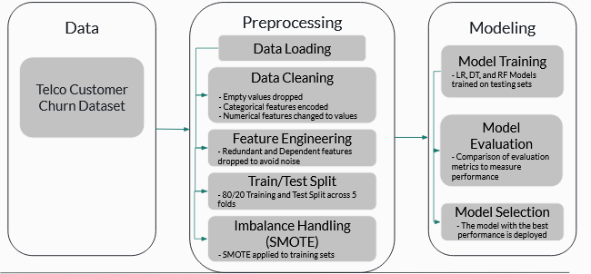

Appendix A - Exploratory Data Analysis
Figure A.1 Gender Distribution
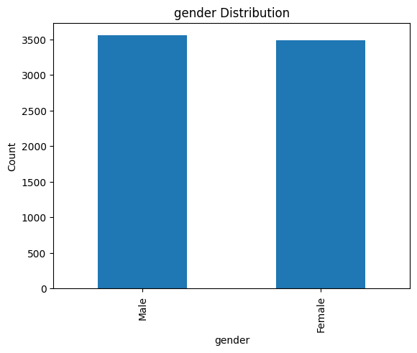
The the dataset contains 3555 males and 3488 females

Figure A.2 - Senior Citizen Distribution
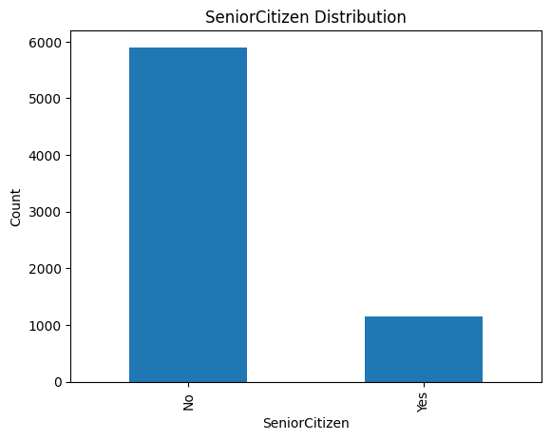
The dataset contains a majority of younger customers with 5901 young and 1142 senior
Figure A.3 - Partner Distribution

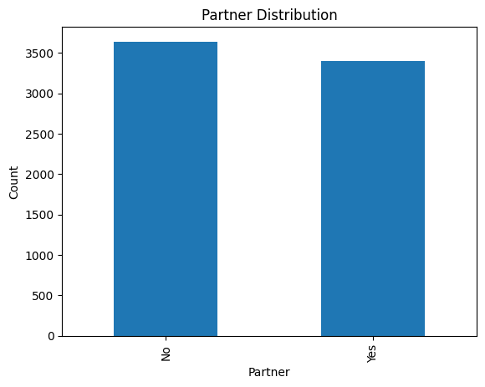
There are 3641 without partners and 3402 with partners

Figure A.4 - Dependent Distribution
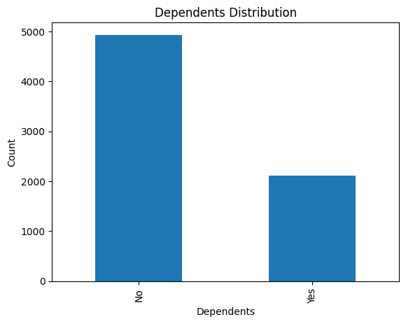
How much relies on the main customer for the service. 4933 who purchase the service for themselves while 2110 have other members using the service
Figure A.5 - Phone Service Distribution
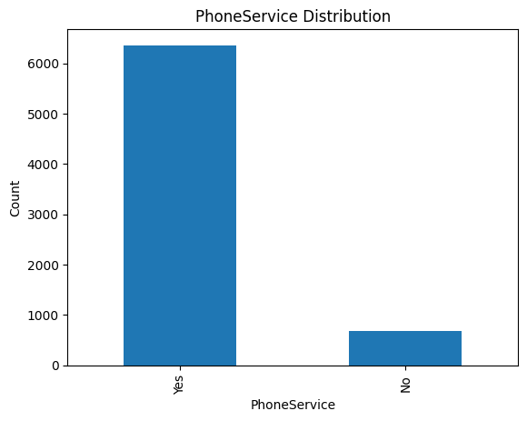
How many obtain the service and is bundled with a phone plan. 6361 has the phone service while 682 has the base version
Figure A.6 - Multiple Lines Distribution
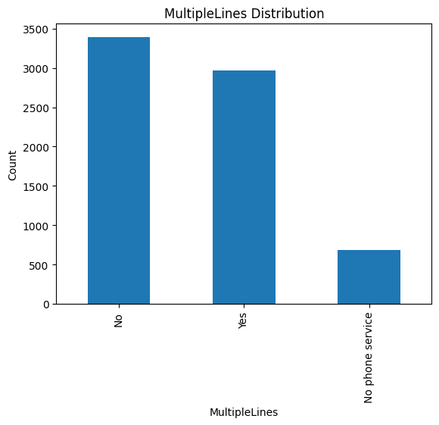
Those who do have the phone service have the option to obtain multiple lines. 3390 have just the one and 2971 has more than one

Figure A.7 - Internet Service Distribution
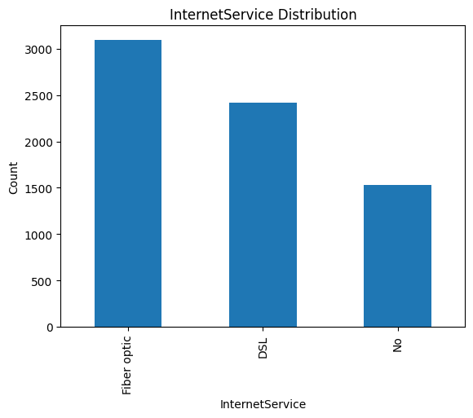
Those who participated in the service included internet access. 3096 opted for fibre optics, 2421 opted for Digital Subscriber Line (DSL), and those who chose not to opt for internet service

Figure A.8 - Online Security Distribution
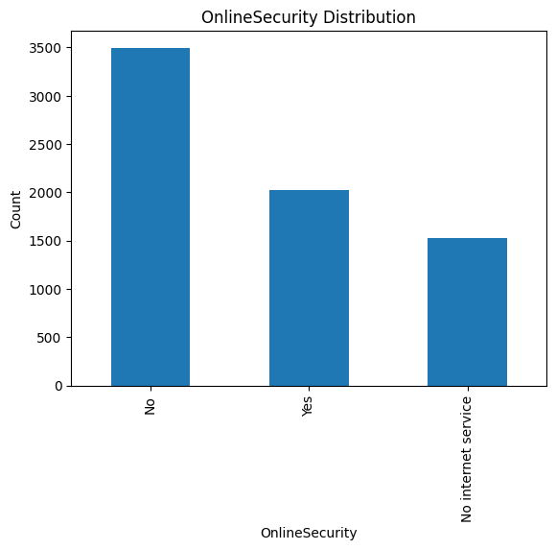
The amount of users who opted for Online Security. 3498 who chose not to include the service, 2019 who chose to include it in their service, and 1526 who doesn’t have internet service

Figure A.9 - Online Backup Distribution
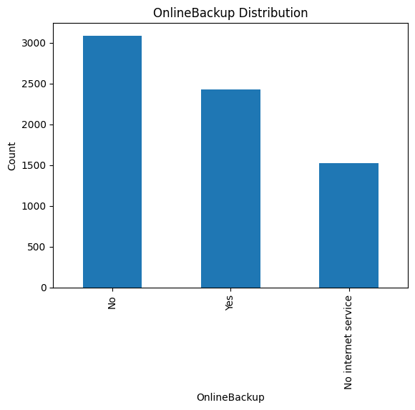
A backup of user data is saved for any unfortunate events that were to happen. 3088 chose not to use this service while 2429 opted for this service, while 1526 didn’t have any internet service.

Figure A.10 - Device Protection Distribution
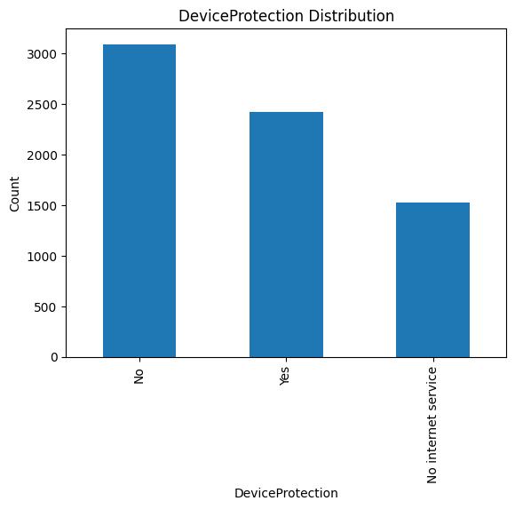
If something were to happen to the customer device, they can choose to have a protection plan. 3095 chose not to include this service, 2422 chose to include this service, while 1526 do not have an internet
Figure A.11 - Tech Support Distribution
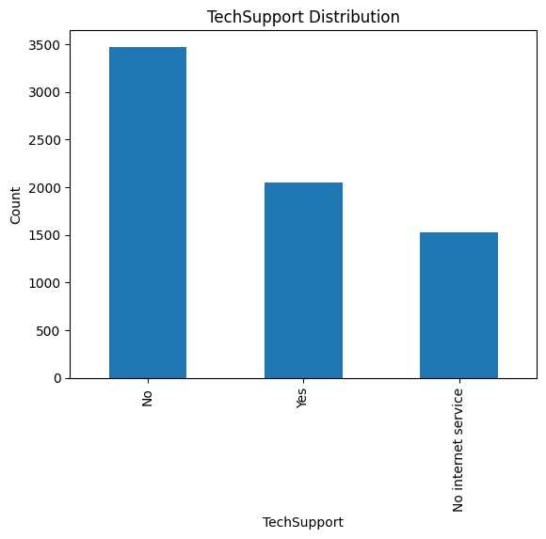
For those who wish to receive tech support they chose this service. 3473 did not include this service, 2044 did include the service and 1526 did not have an internet service with this company

Figure A.12 - Streaming TV Distribution
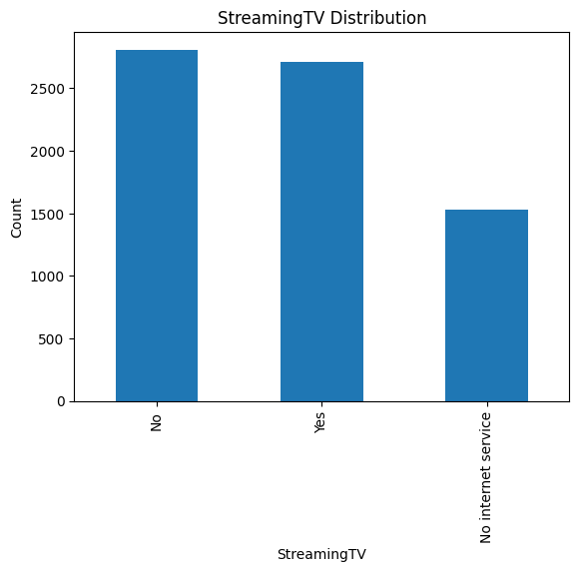
Those who wish to include a streaming service. 2810 opted for the service, 2707 did opted for the service, and 1526 did not have an internet service with this company
Figure A.13 - Streaming Movies Distribution
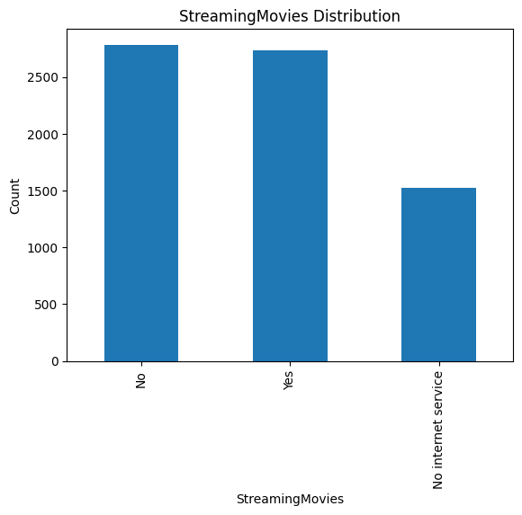
The option for the user to have just the movies for their internet service. 2785 opted not to include this service, 2732 opted to include this service, and 1526 do not have an internet service with this company

Figure A.14 - Contract Distribution
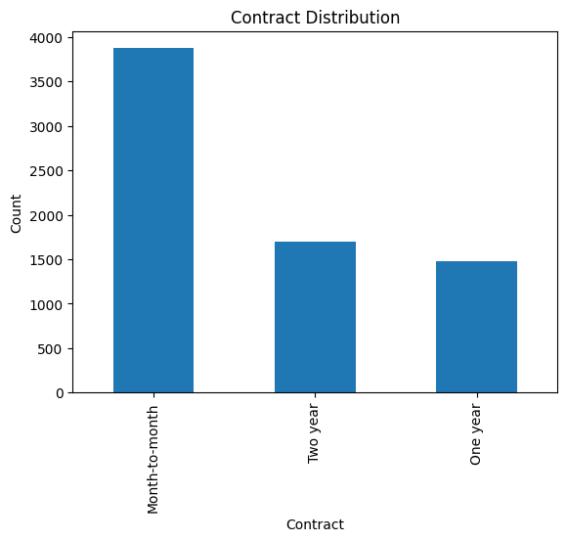
How long the user will stay with this company. 3875 chose month, 1695 chose for a two year service, and 1473 chose for only one year
Figure A.15 - Paperless Billing
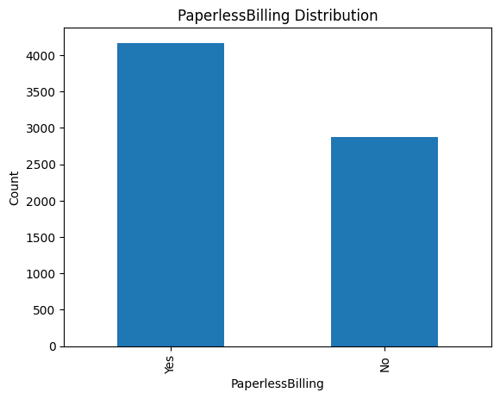
Customers have the options to receive the billing statement via paperless options. 4741 opted for alternative while 2872 preferred the paper statements

Figure A.16 - Payment Method Distribution
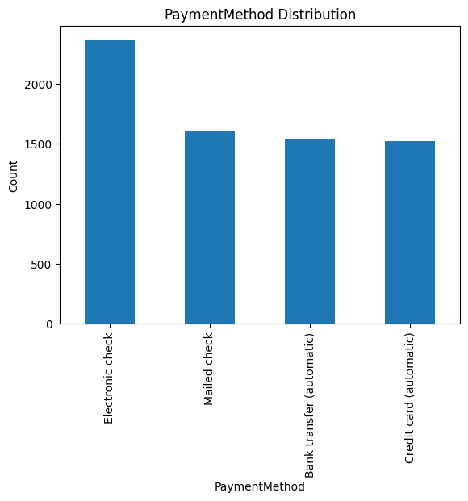
How the user preferred choice of payment. 2365 chose the electronic check, 1612 mailed their check, 1544 had the bank transferred the funds recursively, and 1522 had an automatic payment via credit card

Figure A.17 - Churned
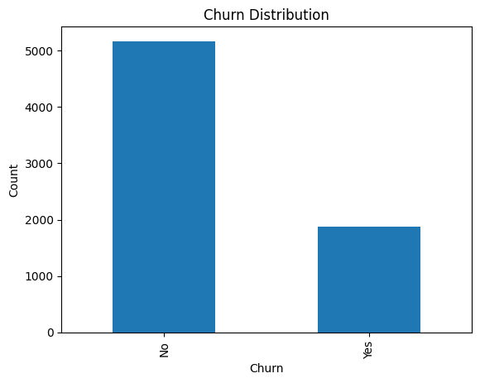
How many customers left the service. 5174 stayed with the service and 1869 chose to find something better

Appendix B - Descriptive Statistic
Table B.1 - Measure of Central Tendency
Feature | Mean | Median | Mode | Midrange
Tenure | 32.4212 | 29.0 | 1 | 36.5
Monthly Charge | 64.798 | 70.35 | 20.05 | 68.5
Total Charge | 2283.300 | 1397.475 | 20.2 | 4351.8

Table B.2 - Measure of the Spread
Feature | Min | Q1 | Q2 (Median) | Q3 | Max | Range | IQR
Tenure | 1 | 9.0 | 29.0 | 55.0 | 72 | 71 | 46.0
Monthly Charge | 18.25 | 35.588 | 70.35 | 89.863 | 118.75 | 100.25 | 54.275
Total Charge | 18.8 | 401.45 | 1397.475 | 3794.738 | 8684.8 | 8666.0 | 3393.288

Table B.3 - Variance and Standard Deviation
Feature | Variance | Standard Devation
Tenure | 6.024698e+02 | 24.545
Monthly Charge | 9.051658e+02 | 30.086
Total Charge | 5.138252e+06 | 2266.771

Appendix C - Additional Visualization
Figure C.1 - Box plot of Total Charge
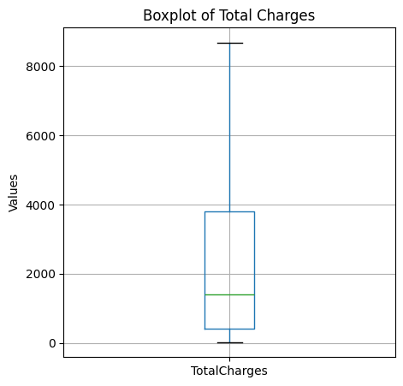

Figure C.2 - Box plot of Tenure
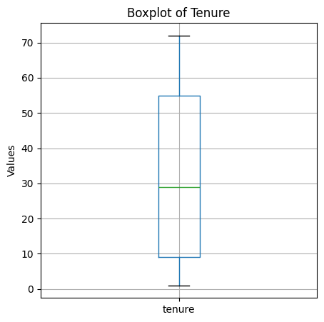

Figure C.3 - Box plot of Monthly Charge
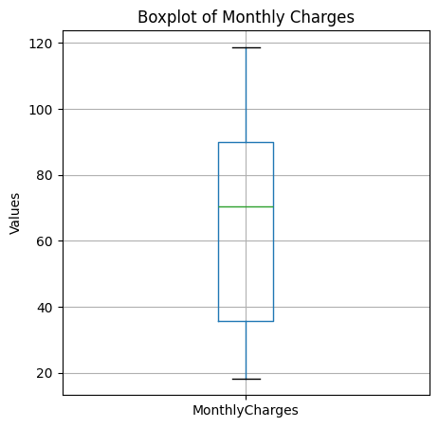

Figure C.4 - Skewness of Fumerical Features
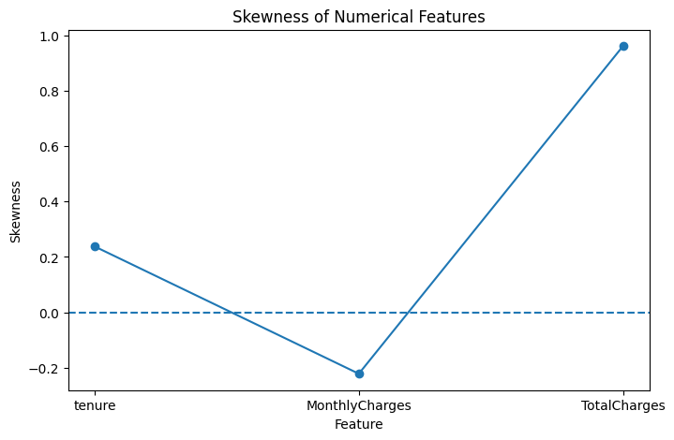
Appendix D - Correlation Analysis
Figure D.1 - Correlation Between Numerical Features and Churn
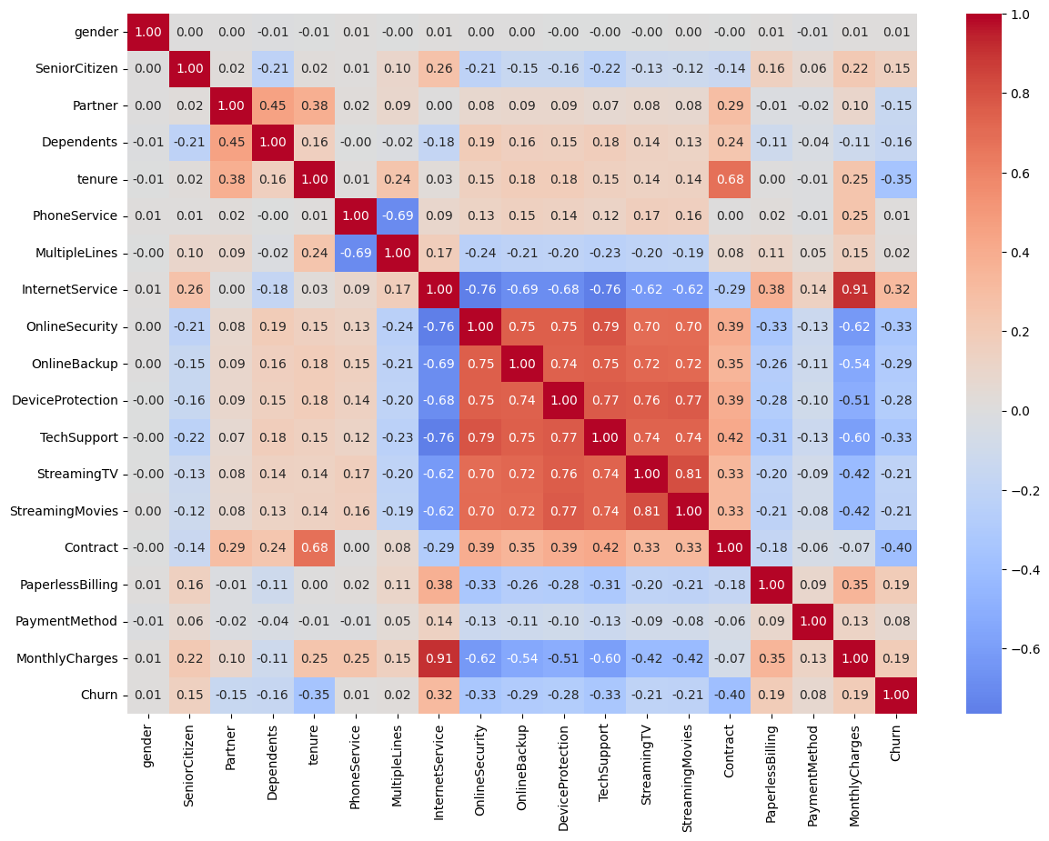
In order to understand how the features in the dataset are related to each other we decided to introduce a correlation matrix, the warmer colors indicate that the value are closely related while the colder colors have the values

Appendix E - Feature selection
Figure F.1
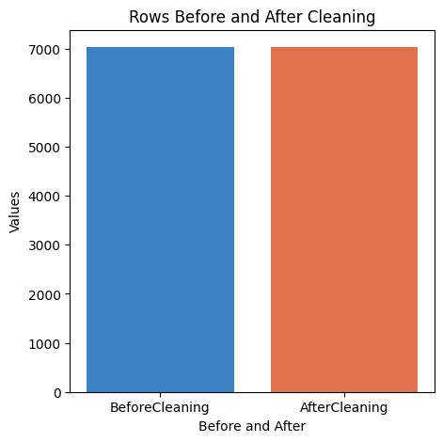
The dataset had missing values that had to be filled or removed to ensure that the model can run as accurately as possible. There was no changes made during the feature selection process.

Appendix F - Selected Source code
https://colab.research.google.com/drive/1Jz8YMOkMUG5cJyDklZAdvAtXVpwF80-A#scrollTo=ArDqHcF_FDBA

The file comes from a Google colab that allows for real time update for each member to make changes to the code

Appendix G - Demo Session

